# Title Page

**(A typical Specimen of Cover Page & Title Page)**

TITLE OF PROJECT

Capstone Project Proposal

**Submitted by:**

101803027 Kshitij Agrawal

101803220 Mohit Sharma

101803548 Sourav Kumar

101983057 Ritish Gupta

**BE Third Year- COE CPG No. 153**

Under the Mentorship of

**Dr. Rajkumar Tekchandani**

**(Assistant Professor)**



**Computer Science and Engineering Department Thapar Institute of Engineering and Technology, Patiala**

**MARCH 2021**

**TABLE OF CONTENTS**

* Mentor Consent Form <Page No>
* Project Overview <Page No>
* Problem Statement …..
* Need Analysis (1 Page) …..
* Literature Survey (3 Pages) …..
* Objectives
* Methodology
* Project Outcomes & Individual Roles
* Work Plan
* Course Subjects
* References

**Mentor Consent Form**

I hereby agree to be the mentor of the following Capstone Project Team

|  |  |  |
| --- | --- | --- |
| **Project Title:** | | |
| **Roll No** | **Name** | **Signatures** |
| 101803027 | Kshitij Agrawal |  |
| 101803220 | Mohit Sharma |  |
| 101803548 | Sourav Kumar |  |
| 101983057 | Ritish Gupta |  |

NAME of Mentor: Dr. Rajkumar Tekchandani

SIGNATURE of Mentor:

NAME of Co-Mentor(if any):

SIGNATURE of Co-Mentor:

# Project Overview

The number of visually impaired people is growing over the past decades. As reported by the world health organization (WHO), about 285 million people worldwide are estimated to be visually impaired, of whom 39 million are blind. However, until now many schools and jobs cannot accommodate them mainly due to lack of assistive technologies and economic barriers. As a result, 90 % of them still live at a low level of income. The major causes of visual impairment are uncorrected refractive errors (43%) and cataract (33%); the first cause of blindness is cataract (51%). Even when the new aids or technologies become available, they are either too expensive ($3000 and above), or affordable ($200) but with single or limited task functions only. In our lives, many people are suffering from different diseases or handicaps. According to NCBI (1986), 1.5% of the population in Saudi Arabia is blind and another 7.8% have vision difficulties. These people need some help to make their life easier and better. The main goal of "Smart Glasses" is to help blind people and people who have vision difficulties by introducing a new technology that makes them able to listen to what is going on in their surroundings. These glasses are provided with technology to scan their surroundings and convert them into audio. Smart Glasses software uses artificial intelligence (AI) to extract different kinds of information from images and then speaks the images out loud so the user has a greater understanding of the environment around him or her. Smart Glasses software provides OCR (Optical Character Recognition) available, and can read any type of text from any surface (e.g., food packaging, posters, display screens, QR and barcodes, handwritten text, etc.), recognize faces, describe scenes, find objects, read documents and letters, and more. Smart Glasses enables blind and low-vision users worldwide to read documents at work, recognize their friends (Face recognition), find personal belongings at home, and use public transport -- independently on their own as well as calculate the number of footsteps to reach a particular object .Among all assistive devices, wearable devices are found to be the most useful because they are hand free or require minimum use of hands. The most popular type is the head-mounted device. Their main advantage is that the device points naturally in the viewing direction, thus eliminates the need for additional direction instructions. This report presents a new design of smart glasses that can assist in multiple tasks while maintaining at a low building cost. The design uses the new raspberry pi 2 single-board computers, a camera, and an earpiece to convey information to the user.

# Need Analysis

The problem faced by them is their inability to read, identify objects and individuals. Most blind people are smart people and can study if they have the chance to be able to study in normal schools because they are government school everywhere. Most people thought blind people and people with vision difficulties cannot live alone and they need help all the times. In fact, they do not need help all the times, they can depend on them self in most of the times and they have the chance to live like a normal person in this life. The main reason for implement “Smart Glasses” for blind people was to prove for all people that blind people and people with vision difficulties have the chance to live a normal life with normal people and study in any school or university without the need for help all the times. By “Smart Glasses”, the percentage of educated people will increase. Our Device aims to solve these basic problems faced by visually impaired people by providing different modes of operation. For people living with low vision, this device opens new doors and creates life-changing opportunities. Thousands of people worldwide will be able to create a new way of life using the device. In addition to a variety of life-changing features, this device is developed with advanced artificial intelligence software capabilities. Currently, one of the main barriers to accessing these vision-enhancing smart glasses is the cost. This puts the financial burden on the user, which will likely prevent the widespread use of smart glasses for now

# Literature Survey

#### LITERATURE SURVEY

This chapter covers the details about the literature review that has been performed, details regarding the existing technology along with the technology on which the team has worked upon are discussed. The theory associated with the problem area has also been discussed in detail.

* + 1. Theory associated with the problem area

Performing simple tasks for the differently-abled can be challenging at times. For the visually impaired an activity as simple as walking can be difficult without any assistance. Be it on streets or even inside their homes people with visual disabilities face problems while walking on their own, often encountering hindrances that can lead to serious accidents and fatalities. Also, due to lack of proper reading material available in abundance a simple activity of reading can also turn into a mammoth task especially for people with complete loss of vision.

With our device, we aim to help the visually impaired perform their day to day activities independently, by providing them with various modes of operations to carry out their tasks. The first mode is facial recognition. This will help people with visual impairments recognize their family, friends, and acquaintances. When a recognized face from the dataset will approach the person, he or she will receive a vocal message via the headset. The user can also save new faces in the dataset as and when required. This will follow a user-friendly approach since new faces can be saved by simply clicking a photo and providing a name using voice commands, via the image processing technique the entry will be saved with a unique name. The second mode that we aim to help with is Text to Speech that will assist people with visual impairments by reading out the text. This also follows a user-friendly approach, since the user will only have to bring the textual material into the sight of the camera and the assistant would start reading it with the help of real-time image processing. The third mode is Obstacle detection. With the help of YOLO and ultrasonic sensor, the assistant will be able to identify obstacles and will alert the

user whenever he or she is in the vicinity of any. Whenever this mode is on, the assistant will use YOLO and an ultrasonic sensor to identify any obstacles. Thus, the user will be able to avoid accidents while walking.

* + 1. Existing Systems and Solutions

Many eye trackers and visual aids are available commercially for the assistance of visually impaired people. These aids serve a different purpose and work on different technologies. Some of them are as follows:

* + - 1. Arduino smart cane for the visually impaired [1]:

This paragraph reports on a study that provides details about an aid that helps the visually-impaired to walk more confidently. The study hypothesizes a smart cane which alerts the user about the obstacles in front. This could help them walk without tripping and avoid serious injuries. The product aims to address the development work of a cane that could communicate with the users through voice alert and vibration, which is named Smart Cane as shown in Figure 2.1 below. Limitations:

* + - * + It can only detect objects at a certain angle, so this product may not be able to detect objects.
        + It can only detect an object but cannot identify the objects.
        + Its application is limited to object detection only i.e. it does not support facial recognition or even text to speech assistance.

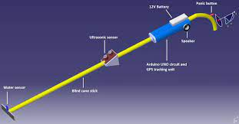

Figure 2.1: Arduino smart cane for the visually impaired

* + - 1. TapTapsee application:

TapTap See is a mobile camera application designed specifically for blind and visually impaired users, powered by the Cloud Sight Image Recognition API. It utilizes the device's camera and voice-over functions to take a photo or record a video of anything and identify it out loud. TapTapSee accurately analyses and identifies any two- or three-dimensional object at any angle within seconds. The device's VoiceOver then speaks the identification aloud [2].

Limitations:

* It cannot perform face recognition.
* The high time of processing.
* It requires capturing a lot of images to detect all objects.
* It works on captured images only, not in real-time. So, this product is difficult for blind people to use.

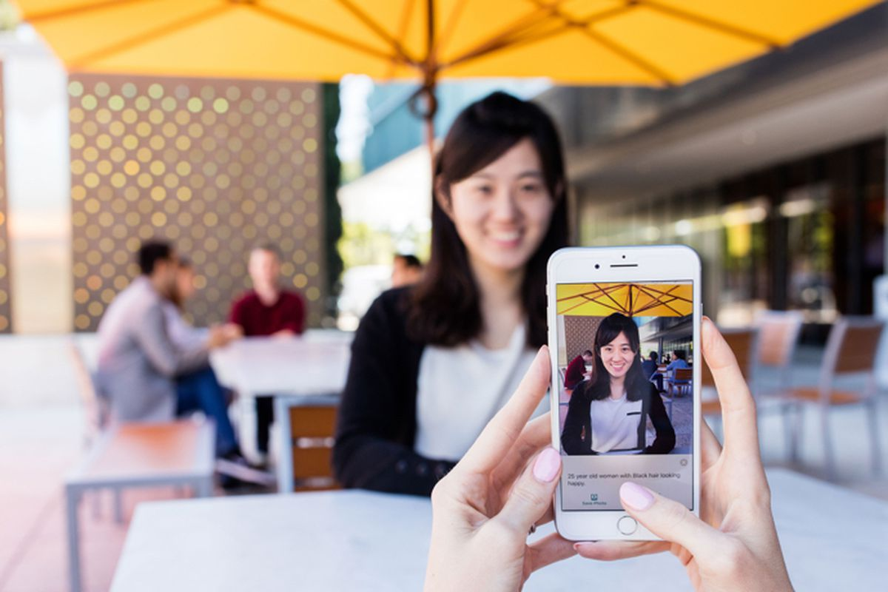

Figure 2.2: Smart app for visually impaired people

* + - 1. Smart shoes for visually impaired people [3]:

The shoe sync with a user's phone and an app that piggybacks on Google Maps allowing the shoes to keep track of where the user is going. Once the users enter the destination and choose a route, they can tuck their phone away and run or walk along with the left or right shoe buzzing. The shoes are for fitness buffs as well, since they are compatible with an app which can track how many calories the user has burned. The app connects via Bluetooth to a module that slides into

the back of the shoe as shown in Figure 2.2 below. The right or left shoe then buzzes depending on which direction the user should turn. Limitations

the back of the shoe as shown in Figure 2.2 below. The right or left shoe then buzzes depending on which direction the user should turn. Limitations

* It is very expensive.
* It detects the objects but does not recognize it for the blind person.
* Processing must be done on a mobile phone so mobile phones are a basic requirement for this product.

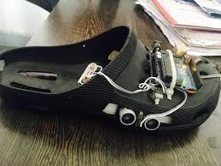

Figure 2.3: Smart shoes for visually impaired people

* + - 1. OrCamMyEye or Smart Glasses [4]:

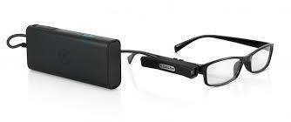This is the best product available for visually impaired people. It has facial recognition as well as to object recognition, which makes this product very helpful for blind people to use. The product is shown in Figure 2.3 below. But there are some limitations to this product. One of them being that this product is not easily available in India at present. Also, this device is very expensive. It is priced at about $4000 i.e.₹ 2.5 lakh. However, considering only the features or applications, this product is similar to our device. But considering the price, our product is more accessible at a very reasonable price of about ₹15000 only. So, our product serves the basic purpose at a reasonable cost. There is another device similar to OrCamMyEye with more features but it also costs about $2000 [6].

Figure 2.4: OrCamMyEye

* + 1. Research Findings for Existing Literature

|  |  |  |  |  |  |  |
| --- | --- | --- | --- | --- | --- | --- |
| S. No. | Roll Number | Name | Paper Title | Tools/ Technology | Findings | Citation |
| 1 | 101803027 | Kshitij  Agrawal | Smart Walking Stick for Visually Impaired People Using Ultrasonic Sensors and Arduino | Ultrasonic Sensors, Arduino Board | Processes signals and alerts blind over any obstacles, potholes, etc. through different  beeping patterns. | [1] |
| Mobile Reading Assistant for Blind People | Text detection, OCR, Speech  synthesis | Automatic text reading assistant. | [2] |
| 2 | 101803220 | Mohit Sharma | Smart shoes for Visually impaired/ Blind people | Ultrasonic sensors, Arduino board, Bluetooth GSM | Location Tracking using GSM | [3] |
| 3 | 101803548 | Sourav Kumar | Research on Daily object detection based on Deep Neural Network | Ultrasonic Sensors, LED, Arduino | Ultrasonic sensors and get the information of the obstacle present in front of the man and processes the  information and sends the output  through the buzzer |  |
| 4 | 101983057 | Ritish Gupta | An automatic speech recognition system for helping visually impaired children to learn  Braille. |  | Detects vowels pronounced  by the user corresponding command and it helps pre-school children  learn Braille system |  |

|  |  |  |  |  |  |  |
| --- | --- | --- | --- | --- | --- | --- |
|  |  |  | Smart Glasses for the visually impaired People | N/A | Text and Object detection and identification help  Blind people. | [4] |

Table 2.1 Research Findings

* + 1. Problems Identified
* **Face Detection**: Detecting faces in real-time with machine learning.
* **Currency Detection:** Identifying the denomination of the currency.
* **Object Detection:** Detecting the presence of any object nearby and identifying its type.
* **Text to Audio:** Converting the text captures in real-time to audio or converting the predictions of nearby objects, faces, and currency to audio.
  + 1. Survey of Tools and Technologies Used

#### For Machine Learning Models

Tools:

1. VS Code
2. Spyder IDE
3. TensorFlow
4. Keras
5. OpenCV
6. Webcam
7. Jupyter Notebook
8. Python Technology used
9. Convolutional Neural Networks.
10. PyAudio
11. Pytesseacrt-OCR.
12. YOLO Framework. **For Real-Time Processing:** Tools:
13. Python
14. TensorFlow
15. Speech synthesis
16. OCR
17. Spyder IDE
18. Webcam
19. OpenCV
20. Keras Technologies Used:
21. Hardcascade face detection
22. LBPH face recognition
23. Yolo object detection
24. Tesseract book reading

#### For Text to Audio Processing:

Tools:

1. Spyder IDE
2. Jupyter notebook
3. PyAudio

# Objectives

● To recognize objects

● To recognize faces

● To be able to read for the user

● To recognize the value of the currency.

● To calculate foot steps..

# Methodology

1.5.1 Face detection

In this step, computer technology is used to detect a face in a picture. This can be

achieved by building a machine learning model trained on a proper data set. The main

focus would be to detect the face in a picture and return a high precision image of the

face bounded by a box.

1.5.2 Object detection

The software will automatically detect the surroundings of the user and inform the user

about the objects present in the surrounding.

1.5.3 Currency detection

In this mode, the software will be able to distinguish between the different currency notes

so that the user can function independently.

1.5.4 Book reading

In this step, the OCR software will be able to help the user to read books, documents,

and convert it into speech for the differently-abled user.

1.5.5 Footstep calculation

In this, the model will calculate the distance of object from the glasses and using a precised formula it calculates the footsteps needed to reach the object.

# Work Plan

* You need to give a short work plan which you will set for achieving the set objectives, in this section.
* Sample:-

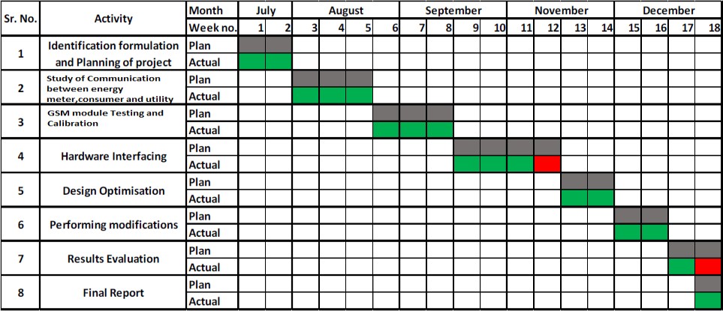–

# Project Outcomes & Individual Roles

World health organization (WHO), about 285 million people worldwide are estimated to be

visually impaired. However, until now many schools and jobs cannot accommodate them

mainly due to lack of assistive technologies and economic barriers

Blindness changes the life of a person. He/she needs

to depend on someone for every small thing. With the enhancing technology at each

end of every sector, the medical department has seen a whole lot of changes to make the life

of a patient easier.

Some people are completely blind, but many others have what's called legal blindness. They haven't lost their sight completely but have lost enough vision that they'd have to stand 20 feet from an object to see it as well as someone with perfect vision could from 200 feet away.

The ultimate motive of this product is to save lives of all kinds of visually impaired patient

as it would make them completely self-dependent and provide them the freedom of their own.

Various features have been integrated into this project covering almost every basic need of

the visually impaired person.

1. Face Recognition: - The glasses will be capable of detecting faces using image processing.

The speaker connected to the device will alert the person that there's someone in his

surroundings. An additional feature to this has been done by recognizing the family

member or a friend's face and his/her name as the audio output

2. Object Detection: - All the nearby objects like table, chair, car and surrounding things will

be detected and audio output will alert the person about its presence.

3. Footsteps Calculation :- By the virtue of precalculation of footstep length by taking the raito of distance and number of footsteps , we will get to know the step length of the person.

And using this value the person will be made aware of how many footsteps he require to reach an object by the audio output.

4. Animal Detection: - Using the local database at the back end the system will be capable of

alerting the person of any animal in the surrounding again using the audio output.

5. Identifying obstacles: - The integrated circuits will help in identifying obstacles in the way.

6. Pothole Detection: - The presence of potholes can be detected by the unevenness of the

surface of the road and help the person to move easily on the road by alerting him.

# Course Subjects

* In this section, you need to list the course subjects that will be used (in the form of conceptual knowledge or practical skills sets) during the successful execution of your capstone project.

# References

**Formatting Guidelines**

* Project Report Type: Transparencies and tape bound
* Number of Copies: 1 per Project group (Max pages 15)
* Running text should be justified, figures and tables center aligned, no space before full stop etc.
* Use **passive voice** in text.
* Paper Size (orientation): A4 (portrait)
* Margins: 1” top / bottom / right and 1.5” left
* Font Type: Times New Roman
* Font Size: 16 bold for Section names, 14 bold for headings and 12 for normal text
* Line Spacing: 1.5 throughout
* Page Numbering: Bottom center of page in the format – Page 1 of N
* All table and figure captions in size 10 sentence case, table captions on top and figure captions below the figure.
* All figures and tables quoted in the text with explanation.
* No figures and equations should be copied. Please use **smartdraw/ visio for figures and Mathtype** for equations.
* References (The listing of references should be typed 2 spaces below the heading “REFERENCES” in alphabetical order in single spacing left – justified. It should be numbered consecutively (in square [ ] brackets, throughout the text and should be collected together in the reference list at the end of the report. The references should be numbered in the order they are used in the text. The name of the author/authors should be immediately followed by the year and other details). References should not be cited from Blogs, Twitter etc. but should refer to good Journal or Conference papers. Typical examples of the references are given below:

**REFERENCES**

1. Ariponnammal, S. and Natarajan, S. (1994) ‘Transport Phonomena of SmSel – X Asx’, Pramana – Journal of Physics Vol.42, No.1, pp.421-425.
2. Anderson T. , Peterson L., Shenker S., Turner J.(2005).Overcoming the Internet impasse through virtualization. IEEE Computer, 38(4):34-41.
3. W. Zeng, H. Yu, C. Lin. (2013, Dec 19). Multimedia Security Technologies for Digital Rights Management [Online]. Available: <http://goo.gl/xQ6doi>